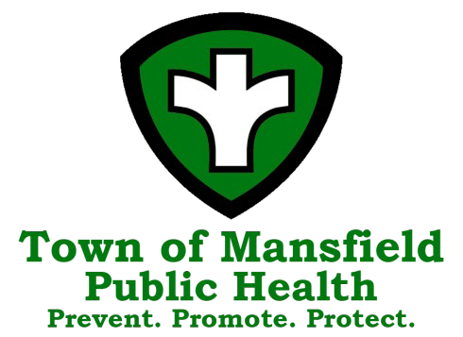
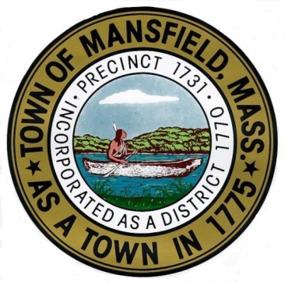
Town of Mansfield
Board of Health Agenda

August 14, 2025 – 7:00 PM

The mission of the Mansfield Board of Health is to protect, preserve and improve the public health, environment and wellbeing of our citizens through the enforcement of federal, state and local statutes and regulations, education and promotion of sanitary living and working conditions, and protection of the environment from disease and pollution.

7:00 PM Call to Order

7:01 PM Correspondence

7:05 PM Consent Agenda (Please see report at end of agenda)

7:10 PM Meeting Minutes
- June 26, 2025

7:15 PM Presentation on Summer internship- Maura Souza

7:35 PM Violations to Regulations Affecting Smoking and the Sale, Vending, and Distribution of Tobacco and Nicotine Delivery Products
    - Town Food Mart
    - West Mansfield Variety
    - Gulf Express
    - Cumberland Farms
    - Dub’s Liquors
    - Town News
    - The Store
    - Citgo/Four Corners Convenience
    - Honey Farms

8:30 PM Tobacco Sales Regulations Discussion
    - Nicotine-Free Generation
    - Inclusion of nicotine pouch restrictions

8:45 PM FOG Variance Request – Hometown Bakery

8:50 PM March 2025 Public Health Nursing report & Infectious Disease Updates

8:55 PM Diversity Equity and Inclusion

8:56 PM Important Dates:
- Free Health Screenings including blood pressure, blood sugar, cholesterol, Hands only CPR and associated prevention information
  - 2nd Tuesday at the COA, 255 Hope Street, 9am-12pm
  - 3rd Wednesday at Town Hall, 6 Park Row, 9am-12pm

8:57 PM Department Updates
- Permitting
- Bristol-Norfolk Public Health Partners Coalition Grants Update
- PFAS
- Website/ Social Media Update
- Housing Inspections
- FOG
- Grants
  - FDA Retail Standards Grant

8:58 PM Visitor Comments

8:59 PM Items not known 48 hours prior

9:00 PM Adjournment

